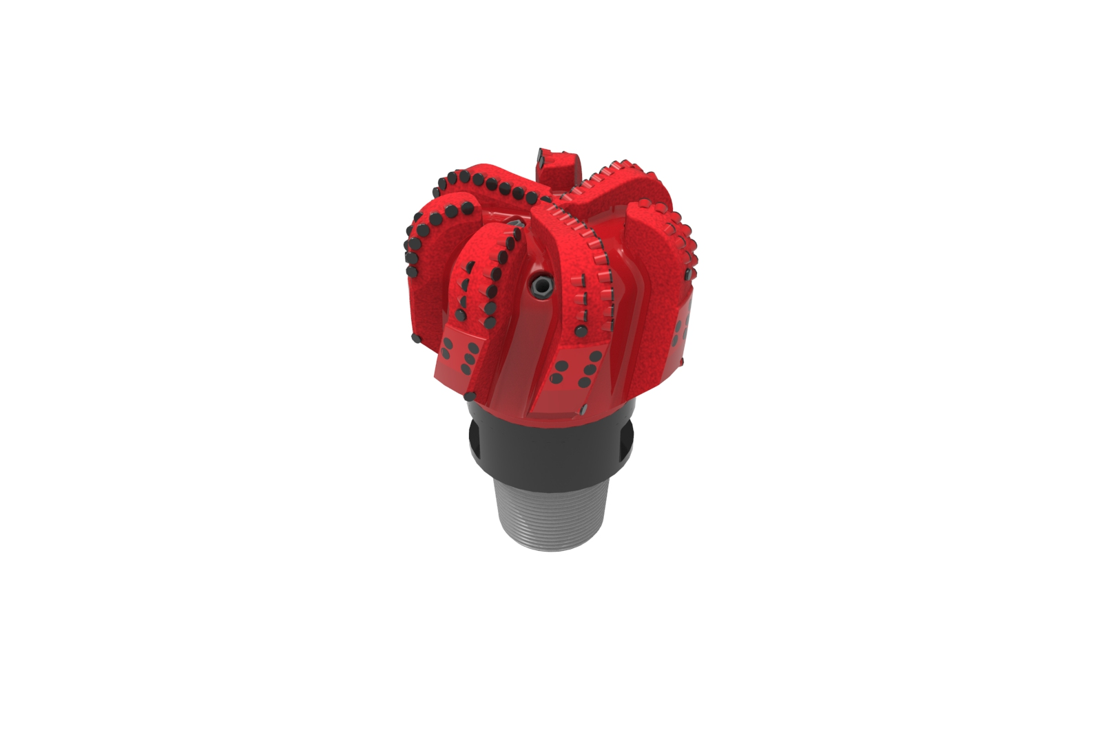
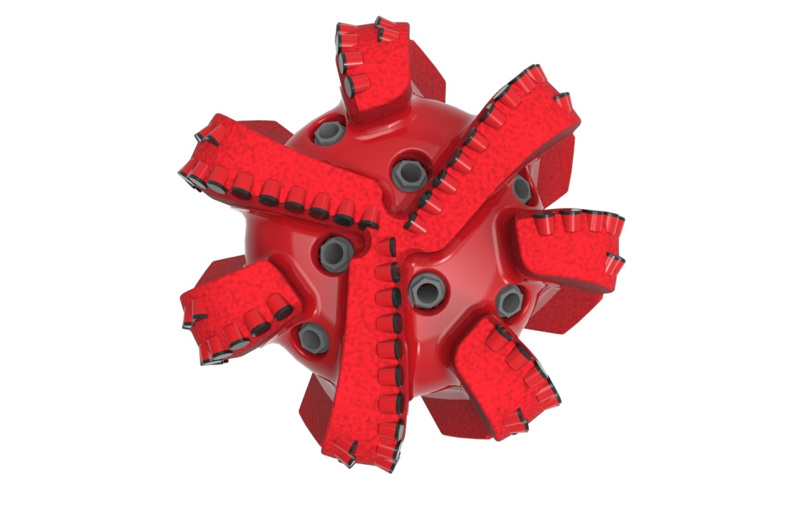

Drill Bit Specifications:
Cutter Size (Primary, Sec) | 5/8”,1/2”
Cutter Count (Total, Gage) | 87,11
Blade Count | 7
Gage Length (Inches) | 3.00
Nozzle Count (Primary, Sec.) | 7
Nozzle Series (Primary, Sec.) | 60
JSA (Sq. Inches) | 32.92
Max. TFA (Sq. Inches) | 3.34
Operating Parameters:
Max. Weight on Bit (1,000 Lbs.) | 60
Make-up Torque (ft/lbs) | 40,563
Nominal Dimensions:
Overall Length (Inches) | 17.87
Make Up Length (Inches) | 13.00
Bit Breaker | SKB-21011
Connection | Ø6-5/8" API Reg.
Approx. Weight (Lbs.) | *220
*Long tool joint available upon request (adds 6” to fishing neck,
makeup and overall length, and 64 lbs to approximate weight).

Tailor-Made Features:

- Premium grade cutters maximize ROP and Life
- Optimized 3” gage: 2” full / 1" tapered
- Nozzle configuration and large open face volume optimize blade cleaning and cuttings removal

713-XR+(K)(BR) Nomenclature Explained:

• | 7 | = | Number of Blades
• | 13 | = | Primary Cutter Size (13mm)
• | XR | = | Backup Cutters
• | 7 | = | Number of Nozzles
• | K | = | Bullets
• | BR | = | Back Reamers


